Home Automation & Surveillance



**Himanshu Khairajani (17100017)**

B.Tech – VI Semester

Department of Computer Science and Engineering

DSPM International Institute of Information Technology - Naya Raipur

Atal Nagar, Chhattisgarh

Email: himanshu17100@iiitnr.edu.in

**Saurabh Pandey (17100049)**

B.Tech – VI Semester

Department of Computer Science and Engineering

DSPM International Institute of Information Technology - Naya Raipur

Atal Nagar, Chhattisgarh

Email: saurabh17100@iiitnr.edu.in

**Saurabh Roy (17100050)**

B.Tech – VI Semester

Department of Computer Science and Engineering

DSPM International Institute of Information Technology - Naya Raipur

Atal Nagar, Chhattisgarh

Email: saurabhr17100@iiitnr.edu.in

Under the supervision of

**Dr. Muneendra Ojha**

Assistant Professor,

Department of Computer Science and Engineering

DSPM International Institute of Information Technology - Naya Raipur

Atal Nagar, Chhattisgarh

Email: muneendra@iiitnr.edu.in

**CERTIFICATE**

This is to certify that the project titled “Home Automation & Surveillance” by “SAURABH ROY, SAURABH PANDEY & HIMANSHU KHAIRAJANI” has been carried out under my/our supervision and that this work has not been submitted elsewhere for a degree/diploma.

(Signature of Guide)

___________________________________________

**Dr. Muneendra Ojha**

**Assistant Professor**

**Department of Computer Science and Engineering**

**Dr. SPM IIIT-NR**

**July 08, 2020**

***Abstract***— Internet of Things (IoT) conceptualizes the idea of remotely connecting and monitoring real world objects (things) through the Internet. When it comes to our house, this concept can be aptly incorporated to make it smarter, safer and automated. This IoT project focuses on building Smart Home with surveillance (using facial recognition system) which sends alerts to the owner by using Internet in case of any trespass and raises a notification optionally. The leverage obtained by preferring this system over the similar kinds of existing systems is that the alerts and the status sent by the ethernet connected microcontroller managed system can be received by the user on his phone from any distance irrespective of wherever the person is. The microprocessor used in the current prototype is the Raspberrypi 3 board which comes with an embedded micro-controller and an onboard ethernet port making use of which all the appliances inside the home can be controlled and managed. Further the voice assistance feature is also proposed to implement using Google Mini Home to make the use of appliances in home little easier for children and old people as well.

1. **INTRODUCTION**

Wireless Home automation and Surveillance is the dual aspects of this project .Our idea is to make everything in home from bulb to water tap of the kitchen smart. Our ptototype can control fans, lights, AC’s and other appliances from anywhere just by using your smart phone. And everyone who is registered to this system will be notified in real-time .A smart door lock is also proposed to be implement for security of Home. Guest interaction system is one of most important feature of our prototype using which one can observe the person who is standing outside the door and can watch and talk as well using the smart home app.Fire safty is one of major issue in today’s world which we can just overcome if get to know ontime . To overcome this problem we have implemented gas sensor which continiously send the data and is monitered by mico-controller , and as per the program it takes the decision to raise an alert. Once the methane level is found above certain therhsold it will cut down the electricity immediately except the kitchen exhaust which will start to pull all the gas outside the home to, make and alert to home owner . If the level of methane is much higher it will turn off everthing and notifie to owner . Here a question should arise in you mind ‘Why different decision ‘ reason is if the gas percentage level in air is less it can be controll by just pullig them out ,but if level is much higher than permissible it can’t be controll just by pulling air and a electric dischage can cause fire, so better to turn off all appliances.

Survelliance and security of home is prime concern for everyone in today’s world . so we have comeup with smart security surveillance which will monitor the suspect using facial recogintion and In case of intuder will send a notification to owner.

1. **RESOURCES USED**
   1. **Hardware requirements-**
      * **Raspberry pi-** The central Processing and controlling part of this system use to send data from sensor to database, control GPIO pin of relay board.
      * 5 Port Relay board – it’s a mechanical switch which works on the **principle** of an electromagnetic attraction. When the **circuit** of the **relay** senses the fault current, it energises the electromagnetic field which produces the temporary magnetic field. ... The current flows through the coil produces the magnetic field around it. The pins are control through the digital circuit. Relay separate digital circuit from 250V voltage which make to use it under any voltage or current without affecting CPU and micro controller.
      * 5 V 2 Ampere Dc adapter- To provide power to relay board, sensors and raspberry pi.
      * Voltage Regulator- A voltage regulator is being designed to operate 240 Volt power supply from digital circuit.
      * Smart phone- To operate android application
      * Bulbs – For demonstration purposes we have used 100-watt bulb
      * Fan – For demonstration purpose to show intensity control of fan speed.
      * Wires – For making internal and external supply of power

**2.2 Software requirements-**

* + Android studio 3.4.0 – It’s an IDE for designing of front end and programming of android application
  + Google firebase (As a database)- As to make our system Realtime and keep record of states firebase database is used. It also triggers the notification
  + Django as a server – This server is running on raspberrypi for continuous monitoring of states from all appliances and keep it up to date on firebase database.
  + GPIO – A digital pins which gives 0,1 states to control the relay and the sensors.
  + XML - for front-end layout in APP
  + JS, HTML, CSS, bootstrap – Tools for designing of web application for home automation.

**3. DESCRIPTION**

**3.1 Product Perspective:**

1. Through web technology and mobile application for controlling and monitoring. User can control- switch on/off the lights and fans in the room.
2. User can operate through mobile app and dashboard switch and also monitor using website by a distant.
3. The security surveillance can be achieved using facial recognition.

**3.2 Product Features:**

1. Status of equipment’s in the House can be checked and monitor through website and mobile application.
2. Switch on/off appliances via voice recognition, mobile app and manual dashboard.
3. Remotely controlled on the System.
4. fast response of website and mobile app for seamless use.
5. Easy to install and set-up.

**4. SETUP**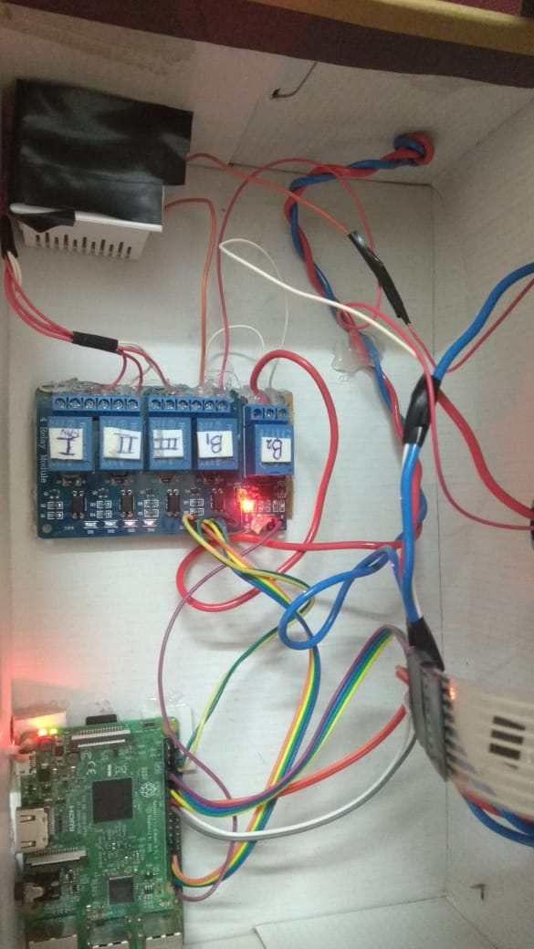

**4.1 Hardware setup: -**

**4.1.1 Raspberry pi:** This is the brain of our system which takes the decision and give instruction to other components.

* 1. Setup raspberry pi for use:
     1. Install the Raspbian os to raspberry pi
     2. Enable the ssh client and vnc viewer or remote access
     3. Install the pyrebase for streaming of data to database
     4. Install the Django for running python scripts
     5. Configure the ports and run the python scripts programmed to control GPIO and sensors

**4.1.2 Relay Module**:

Connect the ground and vin pin of relay to respective raspberry pi board for power

Connect the relay pin 1,2,3,4,5 to 5, 9,13,17,21 GPIO pins of raspberry pi board

Connect all the appliances to relay 240Volt slot for use

**4.1.3 Voltage regulator**: This module is use to control fan speed.

4.1. Connect pin 1,2,3 of Regulator module to relay I, II, III outlet to trigger the required resistance for voltage reduce which cause speed control.

**5
4.1.4 Digital Switch:** The working of these switch is same as conventional switches with only difference, that is connected to database means it behave same as toggled button of your mobile app. Basically it’s a digital switch with conventional working

**4.2 Software setup: -**

**4.2.1 Face Recognition:**

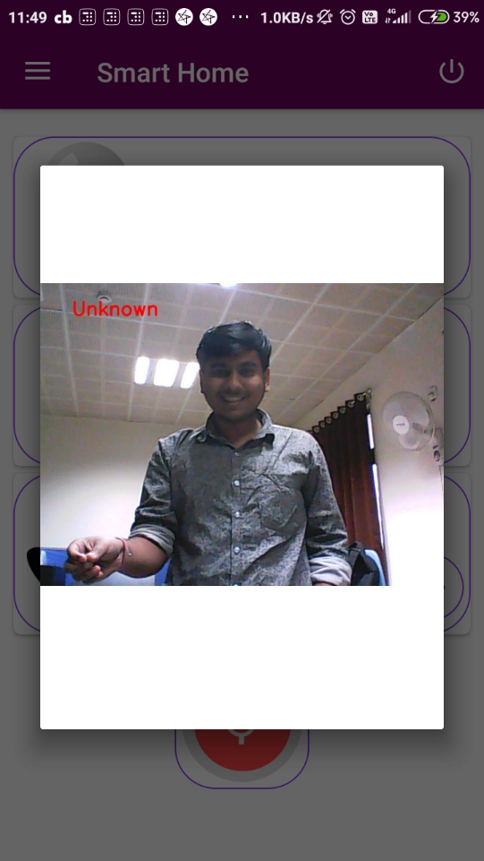

In order to build our OpenCV face recognition pipeline, we’ll be applying deep learning in two key steps:

1. **Applying** **face** **detection**, which detects the presence and location of a face in an image, but does not identify it which is done using dlib’s frontal face detector.
2. **Get face encodings from an image —**Here we are writing the function that will take an image filename and give us the face encodings for that image. Extracting the 128-d feature vectors (called “**encodings**”) that quantify each face in an image and store them.

Further when a fresh frame consisting of a face is taken then following key steps follows:

1. **Compare faces —**Here we are writing the function that will compare a given face encoding with a list of known face encodings. It will return an array of Boolean (True/False) values that indicate whether or not there was a match.
2. **Find** **match** — Here we are writing the function that will take a list of known face encodings, list of names of people (corresponding to the list of known face encodings) and a face to find a match for. It will call the function and return the name of the person with whom the given face matches.
3. If the facial encodings matches with the facial encodings of the existing image then the output would be the name of the person or simple no action will be taken and if the facial encodings doesn’t matches with any existing image then the program will capture the current face and it will send the image of the person to the web and mobile application as pop-notification (as alert).
   * 1. **Smart Home Mobile Application:**

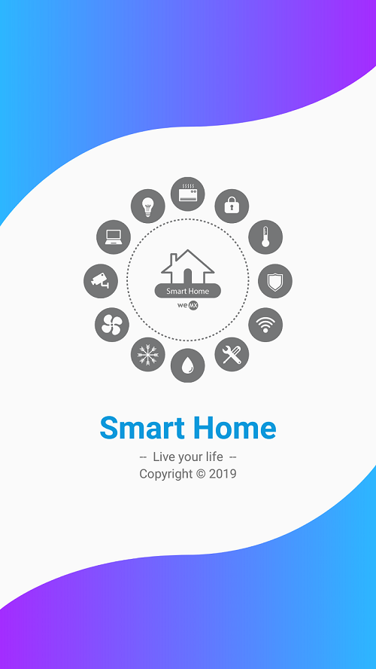 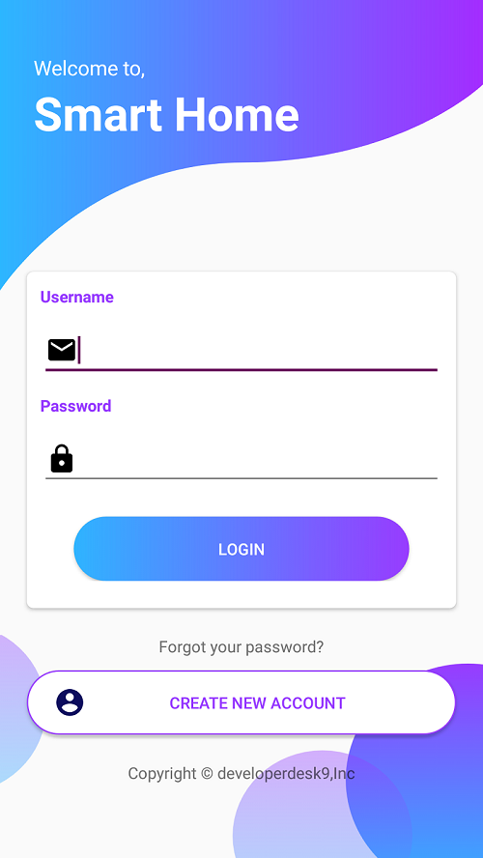

**1. Online Interface** **2. Login Panel**

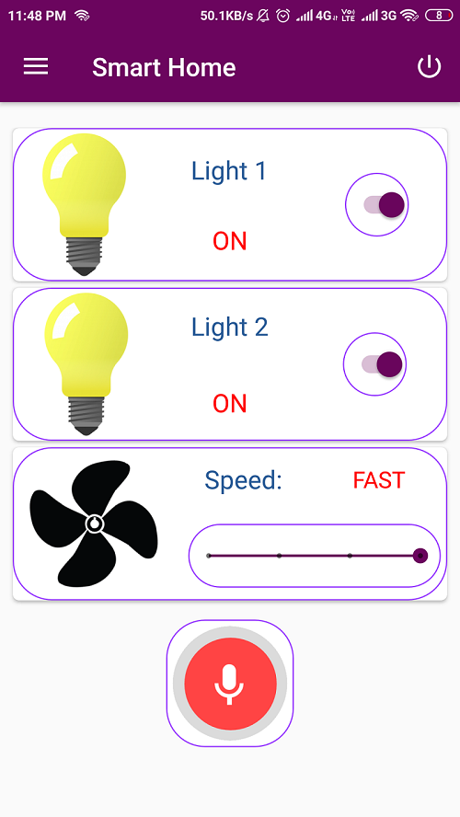 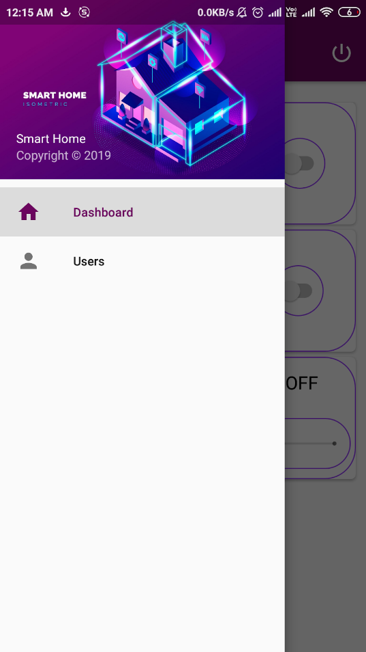

**3. Control Panel 4. Navigation Bar**

**1. Install & open the app.**

**2. Create account & login**

* **Provide your email and create a password.**
* **Fill name and phone number.**
* **Wait for email verification by admin.**
* **Enter you email and password.**
* **Just tap on the login button.**

**3. Control Panel**

* **For now, we have 3 appliances**
* **Tap on the bulb to turn it off or on.**
* **Control the speed of the fan by adjusting the slider.**
* **Click on top right “logout” button to log out.**

**4. Navigation Bar**

* **Admin can navigate between Dashboard and managing Users.**
* **Dashboard for accessing appliances and Users for setting permission for other users.**
  + 1. **Smart Home Web Application:**

[**URL:-**](URL:-)[https://smart-home-1343e.web.app](https://smart-home-1343e.web.app/#header)

There are two webpages in the web application:

1. The **HOME** page as shown in figure: -

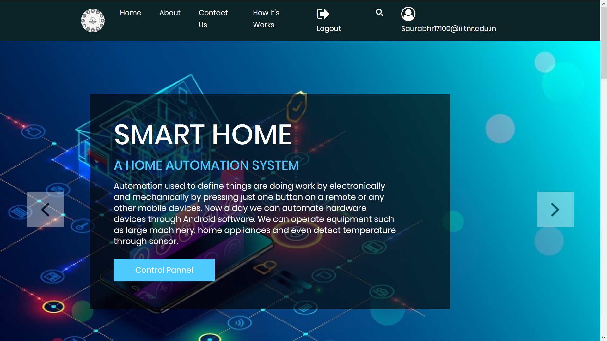

User can **login** using his/her account credentials

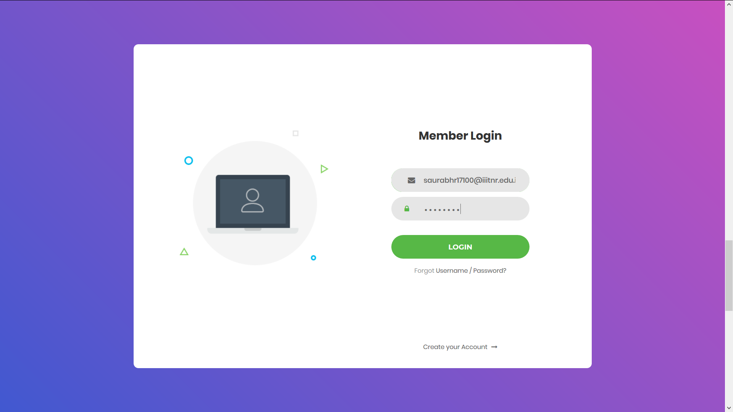

1. The **Control Panel** page: -

User can control different devices by just clicking a button.

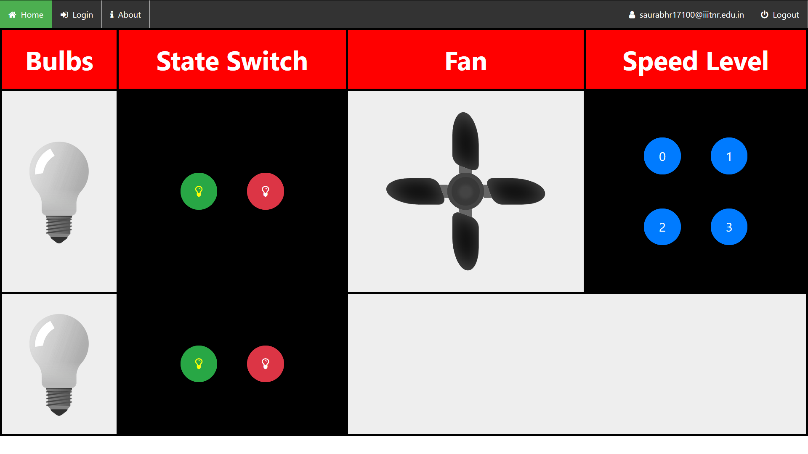

1. **USP’s:**

* **Camera surveillance-** Camera is taking frames and detecting any face in the frame. It is applying face recognition and in case of any UNKNOWN face it is sending an alert to user for intruder
* **Offline access-** In case of no internet connection, the user can easily control using the built-in mechanical switches. The switch is also synched to the database in case the internet is connected.
* **Alert system-** Automatic door locking to burglar-proof the house. Alert to prevent from fire, gas, energy and water leakage

1. **USE CASE FOR SMART HOME:**

Use case diagram used for our project : -

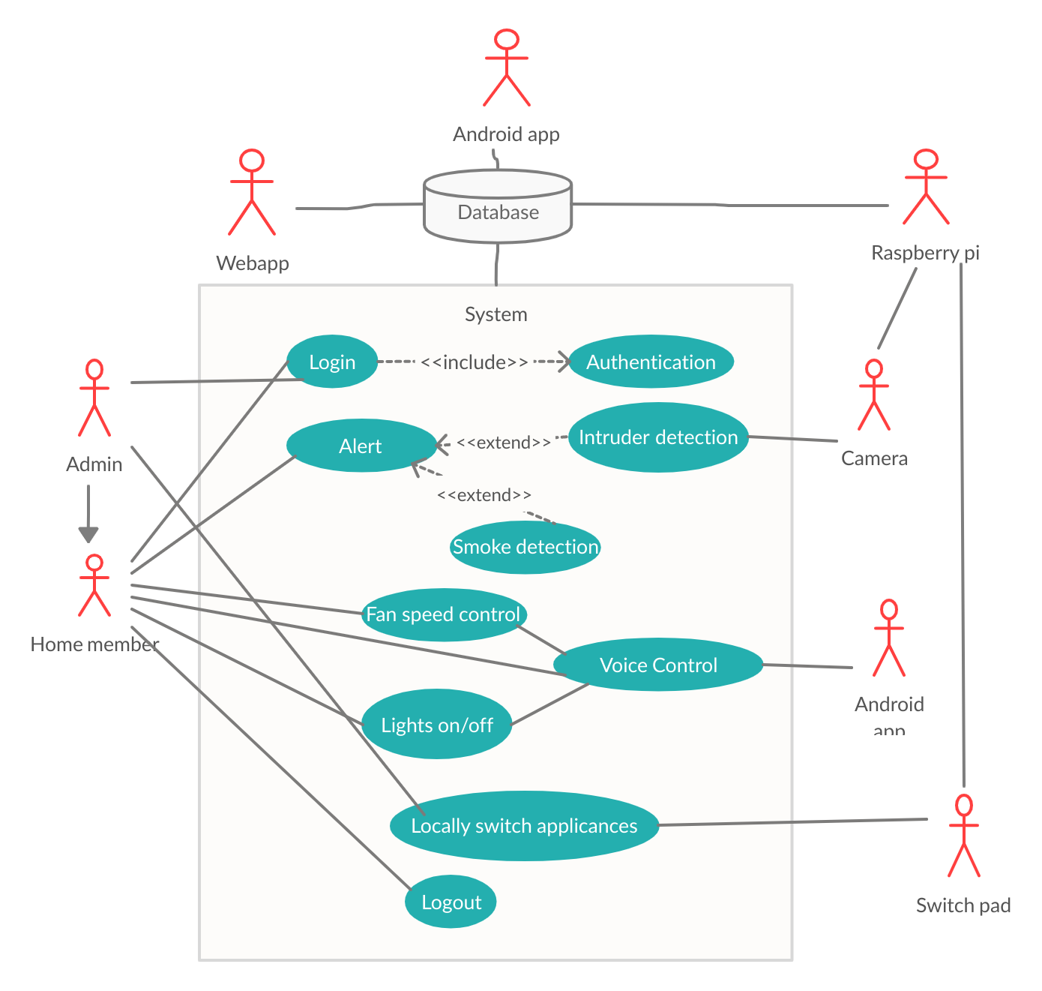

**Key Features**

* Controlling home appliances via mobile or web interface for labor-saving.
* Security alert to detect intrusion, gas leakage and fire.
* IoT based door locking system (future integration).
* Efficient energy conservation.

1. **SOFTWARE MODEL:**

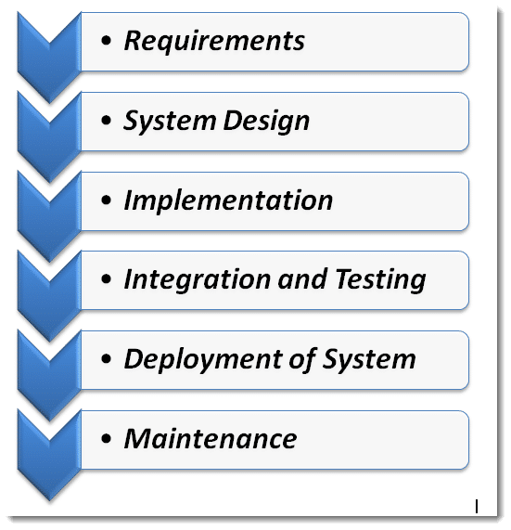

* Waterfall model was opted to make this project.
* It Made easy to first gather all the resources and plans required for this project.
* Then carrying out the proposed model in respective order.
* And finally implementing the software with testing and maintenance made it successfully

1. **CONCLUSION:**

Using this system, we can control any electronic appliances from remote location over internet. The system can be further expanded by including some sensors like light sensor, temperature sensor, gas sensor etc. and automatically adjusts different parameters like room lighting, air conditioning (room temperature), door locks etc. and transmit the information to our server which can be viewed from anywhere.

1. **REFERENCES:**
2. *Warsuzarina Mat Jubadi* and *NormaziahZulkifli*, “Programmable Infrared Accessory Light   Switch”, International Conference on Intelligent and Advanced Systems, Kuala Lumpur, (2007).
3. *ShopanDey, Ayon Roy* and *SandipDas*, “Home Automation Using Internet of Thing”, IRJET, (2016).
4. *A. M. D. Celebre, A. Z. D. Dubouzet, I. B. A. Medina, A. N. M. Surposa* and *R. C. Gustilo*, “Home automation using raspberry Pi through Siri enabled mobile devices”, International Conference on Humanoid, Nanotechnology, Information Technology, Communication and Control, Environment and Management (HNICEM), Cebu City, (2015).
5. *Mandurano, Justin,* and *Nicholas Haber*, “House Away: A home management system”, IEEE Long Island Systems, Applications and Technology Conference (LISAT), Farmingdale, NY, (2012).